**Healthcare Project 1**

**DATABASE Schema**

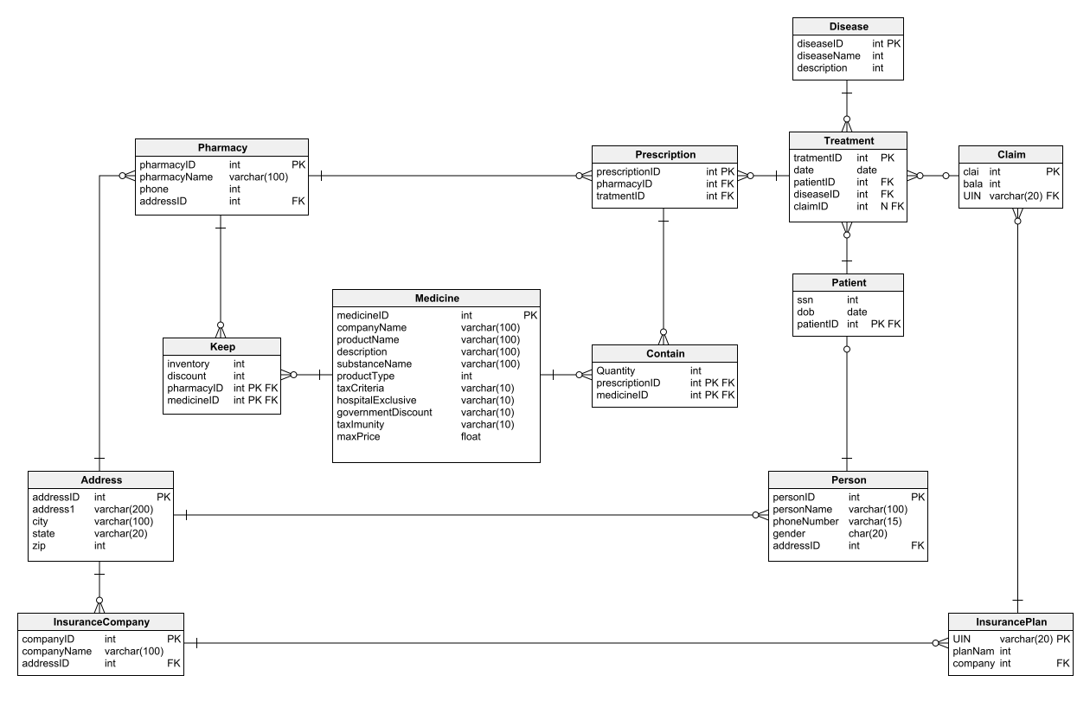

For the given Healthcare database write queries to find the following.

1. SELECT the age of the patients and the number of treatments they have gone through, sorted by the number of treatments in descending order.  
   SELECT the top 5 rows only.

Expected Headers of Query:  
age numTreatments

1. Find the number of male and the number of female patients who were treated for 'Bipolar disorder'.

Expected Headers of Query:

gender numTreatments

1. Find the top three cities which had the maximum number of treatments for 'Cancer'.

Expected Headers of Query:

city numTreatments

1. Find the company name, address, and the number of claims for each Insurance company.

Expected Headers of Query:

companyName numClaims street city state zip

1. Find for which disease how many insurance claims are being made.

Expected Headers of Query:

diseaseName numClaims